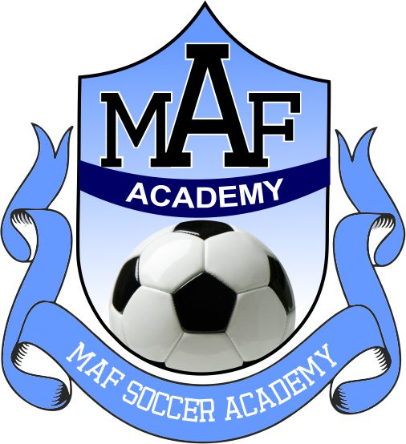
MAF Soccer Academy - Parent Expectations

Thank you for being a part of our MAF family. We appreciate your support and encouragement. It is important for coaches, players and parents to act and represent our organization in a positive manner on and off the field. Our primary goal is to cultivate a positive environment for our players and families and we need your help to do this.

Always be positive. Encourage all of the players and be supportive. Keep negative comments to yourself. The players and coaches are doing their best.

Do not coach the players. Let the coaches make adjustments as they see the need. Many times the instruction from a spectator contradicts the instruction given by the coach. Allow the players the freedom to make their own decisions and learn from their mistakes. All Players will get playing time during game days. Certain players may play more than others. The coach will decide what is best for the team.

Treat the officials respectfully. All officials make mistakes. Let the coaches approach the officials if they feel they need to discuss a call.

Do not engage in arguments with parents from the opposing team. We want to be known as an organization that is well respected - whether we win, lose or draw. The score will not be remembered, but inappropriate remarks will be.

Leave the game on the field. When the game is over, no amount of comment, question or discussion with the players, officials or coaches can change the outcome. The coaches will evaluate the team’s performance; reinforce the good things and work to correct the things needing improvement.

Reserve the use of emails for exchanging information only. If you or your player have any concerns, encourage your player to address it with the coach - in person, not via email or phone. If you would like to be present, we are happy to speak with you - but the player should also be present.

Keep the game fun. Winning is more fun than losing, but each player should enjoy playing because they love the game.

